KNIT YOUR FEELINGS

Instructor
Kendall Ross

Start Date | Rain Date
Eight-week class begins Monday, July 10th, 6-8:30 pm.
In case of instructor illness or weather, the rain date is September 4th.

Location
Studio School Building | Flex Studio | 2 NW 11th St., Oklahoma City, OK, 73103

COURSE OUTLINE

Week 1
Students will receive an overview of different knitting materials, fibers, and history. Students will learn how to cast on, count stitches, knit, and correct mistakes with a crochet hook. Students will create a garter stitch swatch.

Week 2
Students will learn how to cast off, weave in ends, purl into a stitch, and count rows. Students will learn how to alternate between knitting and purling rows to create a stockinette stitch swatch.

Week 3
Students will learn how to read a knitting pattern, change colors to create stripes, and alternate between knitting and purling on the same row. Students will make a striped swatch.

Week 4
Students will receive an overview of different colorwork methods in knitting and learn how to choose yarn for colorwork. Students will see examples of colorwork pieces, journal, and design their own colorwork chart. Students will learn how to read a chart and knitting pattern. Students will work on stockinette stitch swatches to use for their pieces.

Week 5
Students will learn how to embroider text and images from their colorwork charts onto their knit swatches using duplicate stitch. Students will create a piece on their swatches using their own colorwork charts.

Week 6
Students will learn intarsia and how to color block using two colors of yarn.

Week 7
Students will design a colorwork chart and learn the basics of Fair Isle knitting. Students will begin a stranded colorwork piece.

Week 8
Students will continue their Fair Isle pieces. Students will present and critique their finished projects from the session with the class.

REQUIRED MATERIALS

- Yarn
  - For weeks 1 and 2, we will be working with one color of yarn at a time. In class, we will go over materials and how to purchase yarn for your colorwork pieces. For the first two weeks, please come prepared to knit with any yarn you like and the needles suggested to go along with that yarn.
  - When you buy your yarn, it will have a label similar to the one below with information on it about the yarn, including what size needles to buy. I would recommend buying a yarn that is medium weight or larger. For medium weight it should say worsted or size 4 on the label. Size 5 or 6 will also work. I would also get a lighter color and not navy or black so it is easier to see your work. Here is an example of worsted weight yarn.

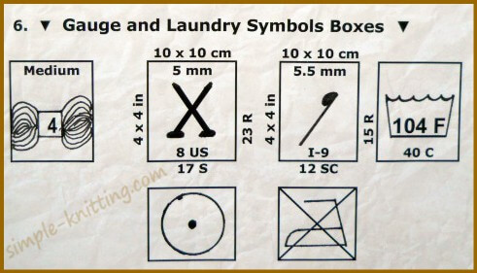
  - You can find yarn anywhere, including art stores like Joann or Michaels. There are also a couple small businesses in OKC where you can get higher end yarn. If you buy from one of these small businesses, make sure the yarn is in a ball or skein and not a loose hank (here is the difference).
    - Yarnatopia
    - A Chick that Knitz
- Knitting needles
  - Buy knitting needles that match the recommendation from the yarn you buy (for worsted weight yarn that would be size US7-US9). On the label, the recommendation will be by the image of the knitting needles.
  - I would recommend starting with straight wood needles similar to these.
- Crochet hook (this is for correcting mistakes, so any size from 4mm (G) to 6mm (J) will work)
- Yarn needles
- Graph paper (you can also just print this off online)
- Colored pencils or crayons
- Measuring tape or ruler
- Scissors
- Way to journal (could be phone/laptop/piece of paper)

ADDITIONAL RESOURCES

Row counter app and Stitch fiddle

